**ESSAY TOPIC:**

**IF I COULD INVENT SOMETHING NEW**

**STUDENT’S NAME:**

**DESTINY ANIEFIOK**

**NAME OF SCHOOL:**

**LIORA INTERNATIONAL SCHOOL, PORT-HARCOURT**

**CLASS:**

**JSS 1B**

If I could invent something new, it would be a vehicle-robot.

First and foremost, I would like to define the two terms involved. What is a vehicle? A vehicle is an automobile or a machine that runs on fuel or diesel, from one place to another. While a robot, is a micro-chip machine that can do anything it has been programmed to.

Now the terms put together; a vehicle-robot is a machine that can move from one place to another, powered by a micro-chip, can transform into any shape as well as has the ability to carry out amazing instructions. It can be used on land, air and water. Only adults from 18 years and above should be allowed to ride and own it.

The vehicle-robot can help those who sell stuffs reach a wider audience since they can move from one place to the other, advertising their wares. For people who intend to shop or sell in faraway places, the vehicle-robot could help them reach their destinations effortlessly, and the best part is that it runs on a game-yoo play which win coins that can also be used to power it up.

In addition, it has some modes added to its motherboard like van-mode and house-mode; this enables it transform into any. Let me explain.

The van-mode is a moving truck, like the American ice-cream truck where goods are displayed at the back of the truck by a robot, while it is been driven. The robot dances to music being played which attract customers. It can either be self-driven or person-driven.

If it were possible, I would love to meet His Excellency, the President of the Federal Republic of Nigeria, President Bola Ahmed Tinubu, and explain the need for him to help the Nigerian citizens in building industries were these vehicle-robots could be built, so they would go a long way in improving lives.

Also, the Minster of Education, Professor Tahir Mamman, could see the need to infuse in our school curriculum, courses on the building of robots that can perform different tasks.

Now back to my explanations, the house-mode can be liken to a house made of metal which can also serve as a shop. This way, if you have a visitor and you are far-away from home, you can easily receive your visitors in your vehicle-robot, entertain them and make them feel at home.

These vehicle-robots could come in various sizes and colours.

A sample of the vehicle-robot is shown below in Pic 1:1

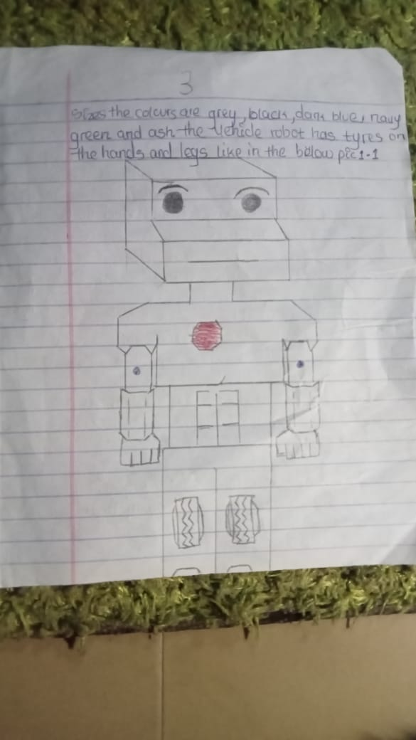Pic 1:1

They have the ability to change into any form hence, they can also be called **TRANSFORMERS.** And because they can run on water, be driven on land and flown on air, they are capable of solving a major mobility challenge and would help create employment for the youths of Nigeria.

Finally, my sincere appreciation goes to the CEO, Heirs Insurance Group , Mr Tony Elumelu; the entire management and staff of Heirs Insurance Group for giving us this opportunity to come up with creative ideas to help solve the teeming problems of humanity.

Long Live Heirs Insurance Group,

Long Live the Federal Republic of Nigeria.