Essay: If I could invent something new.

My name is Naomi Naro Meni-Elabha. If I had a chance to invent something new which would be favourable for mankind it would be automatic machine that can reduce the impact of pollution in our environment, it will look more like a nebulizing apparatus. As an indigen of Oloibiri since 1956 when oil was discovered the leakage caused a lot of penile to lives of people in the community. Originally as an island the major occupation of the people was fishing after the oil leakage this resulted into death of marine and damaged the eco-system. The water became toxic that resulted into death, heart damage, stunted growth etc. The present-day Niger Delta is left with the following problems; oil spillage, loss of mangrove forests, depletion of fish population, natural gas flaring, movement of protection of Niger Delta. These activities have led to unemployment of youth in their effected community which have led them into illegitimate refinery even with the at treacherous factor that goes with it causing air pollution. Currently our environment is being contaminated which is now leading to respiratory tract diseases, lung cancer etc. Those days when there was no refineries people lived long and they don’t fall sick easily. Now our days it causes global warming, hazards to wild life and so on. Basically, that’s why I would like to invent a machine that can reduce the impact of pollution in the environment.

Firstly, my invention would help to decrease cardiovascular disorders caused by pollution. As statics shows pollution in big cities as well as small ones. Especially, during working hours in your work place when something is burning you can start reacting to it. It can also lead to you being hospitalized and makes you spend money but my machine will definitely help reduce the impact of pollution on man’s health.

Secondly, in the result of this invention there could be decrease of jeopardises in food which is caused by soil pollution which is also risk to human health both indirectly through the consumption of contaminated food and drinking water, and directly through exposure to contaminated soil, sometimes people don’t know how to discard harmful material in our environment which leads to depletes of aquatic eco-system, chronic obstructive pulmonary disease etc. I believe there is only one solution to these problem, my automatic machine should be obtainable.

And finally it would be great to see people healthy and strong so that human, animals and plant can enjoy life.

In conclusion, I would like the machine to look like an apparatus and it can prevent you from in haling bad substance in the air using my invention. This invention would be very advantageous for people in the environment.

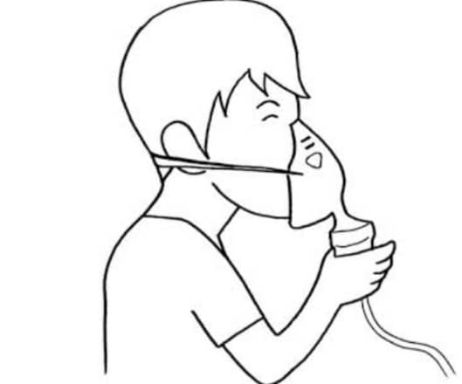

Nebulizer Cup: Changes liquid medicine into fine droplets (in aerosol or mist from) that are inhaled through a mouth piece and mask.

Tubing: Delivers the pressurised air from the compressor to the medication cup.

Mask: Allows the medicine to enter the lungs directly .