**If I Could Invent Something New: The EcoBuddy**

Name: Miracle Okoro

Class: JSS 2

School: MaryGold Int’l School

Imagine if there was this awesome gadget called the "EcoBuddy" that could help save our planet and make life easier for everyone. It'd be like a cool wristwatch from the future but way smarter!

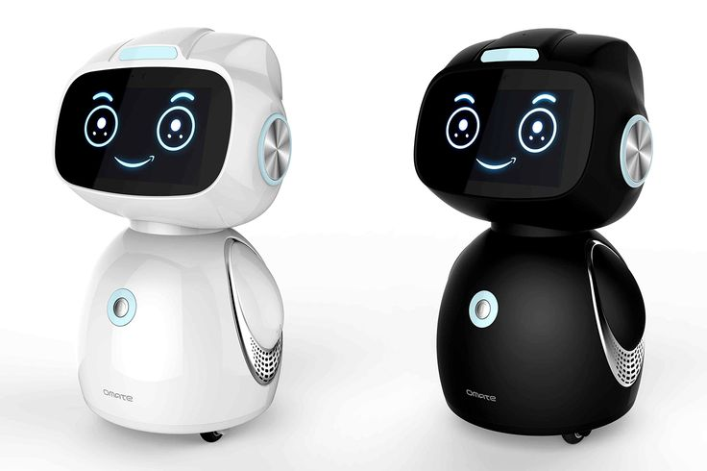

The EcoBuddy would have a screen you can touch and a super cool sensor that checks the air quality. If the air isn't good, it would tell you to wear a mask or stay inside. It'd also show you the best parks where the air is clean so you can hang out safely with your friends.

It's not just about air though. The EcoBuddy would help save energy too. It'd talk to your appliances and tell you if you're using too much electricity or water. And if you forget to turn off a light, it'd give you a heads-up. It'd even suggest things like using energy-saving bulbs or taking shorter showers to save energy and money.

And guess what? It's also a recycling pro! With a built-in scanner, it can read barcodes on stuff and tell you if it can be recycled. If not, it'd suggest eco-friendly options. Plus, it'd help you keep track of how much you recycle and give you tips to do it better.

But wait, there's more! The EcoBuddy loves the outdoors. It'd have GPS to find the coolest trails, parks, and nature spots near you. You could count your steps, stay active, and take awesome pics of plants and animals. Then you could share your discoveries with your family and friends.

And the best part? You'd join a big group of EcoBuddy users all over the world. You could swap tips on living green, join challenges to see who can help the Earth the most, and earn cool rewards for being eco-friendly. Together, we'd be like superheroes saving the planet!

So, with the EcoBuddy, you'd not only help make the air cleaner and save energy and recycle better, but you'd also have a ton of fun exploring nature and making a big difference for our planet!