**OLUWAMAYOMIKUN AJAYI**

**CALEB BRITISH INTERNATIONAL SCHOOL**

**JSS2**

**TITLE: If I could invent something new: A cure for Sickle Cell Disease**

If I could invent something new, it would be a cure for sickle cell disease. Sickle cell disease is an inherited blood disorder caused by the inheritance of two S genes from the mother and the father. It affects haemoglobin, the protein-carrying oxygen, thereby interfering with oxygen delivery across the body. Rather than the typical flexible and biconcave-shaped red blood cells, the red blood cells become crescent or sickle-shaped preventing blood flow to the rest of the body. These sickle-shaped red blood cells block blood and oxygen flow to organs and deprive them of blood and oxygen. This deprivation of blood and oxygen flow leads to sickle cell anaemia. It is mostly common among black Africans.

The problem is that sickle cell disease is associated with morbidity, mortality, and low quality of life. In Africa people with sickle cell disease especially those from low socio-economic backgrounds suffer a lot because of weak health systems, poor quality of care, and inability to afford treatment.

People with sickle cell disease or anaemia are vulnerable to infections especially ulcers in the lower leg and foot. This is because sickle cell anaemia affects an organ known as the spleen which helps filter blood. Sickle cells get stuck in this filter and die, blocking blood flow to the spleen which can cause painful swelling.

My solution therefore is to design a cheap drug that would prevent couples who are carriers from having a baby with sickle cell disease. This drug would be a tablet that both the man and woman would take to prevent having a baby with Sickle Cell Disease. I would also make a related drug that would convert a person who already has Sickle Cell Disease to an AA genotype. This drug would be a tablet that is taken once and can make the person's bone marrow start producing red blood cells with the AA genotype. It would be a cheap cure for this disease. It would change the lives of black Africans and let couples get married without the fear of bearing a child of genotype SS. It would bring in a new chapter for genetic engineering and modification. This approach gives hope to future generations and helps affected couples deal with their emotional burden and reproductive dilemmas.

In conclusion, developing a cure for sickle cell disease would revolutionize medical science and significantly improve public health, especially in high-prevalence regions like Africa. A preventive drug for carriers and a transformative treatment for those affected would address the genetic root and offer a definitive cure, enhancing the quality of life for millions. This innovation would reduce economic burdens, promote equitable healthcare, and advance genetic engineering. It would empower couples to make informed reproductive choices, fostering healthier communities. Ultimately, eradicating sickle cell disease would symbolize a triumph of human ingenuity, marking a hopeful chapter in medical history and paving the way for resilient future generations.

[[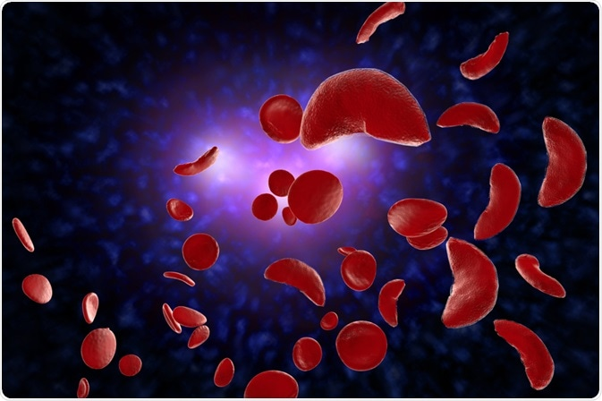](https://www.news-medical.net/health/Treatment-Options-for-Sickle-Cell-Disease.aspx)673 × 448](https://www.news-medical.net/health/Treatment-Options-for-Sickle-Cell-Disease.aspx)

A PICTURE SHOWING SICKLE CELLS

[[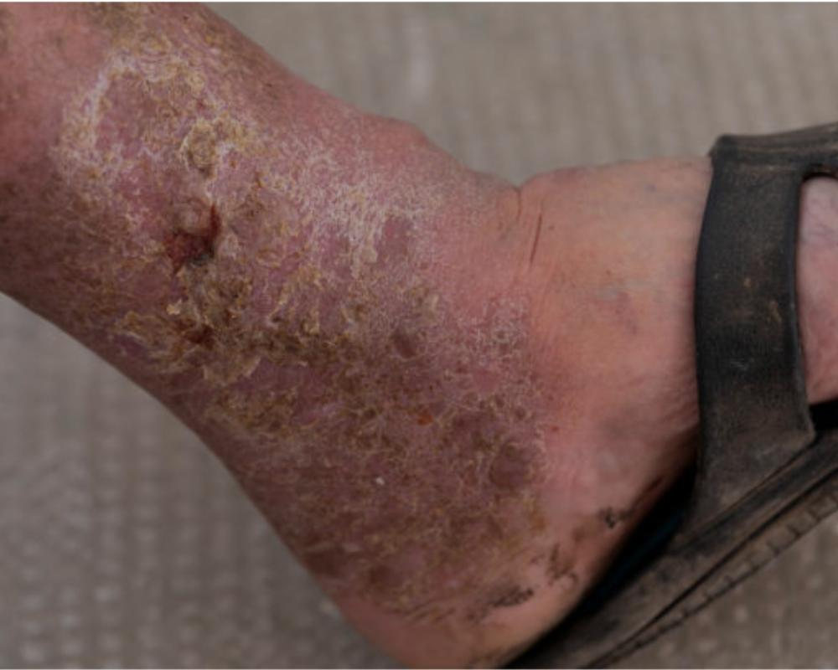](https://www.google.com/url?sa=i&url=https%3A%2F%2Fwww.southvalleyvascular.com%2Fpost%2Fleg-ulcers-symptoms-causes-and-treatments&psig=AOvVaw18TyScoPJeiuSjESiyYeBE&ust=1717605423848000&source=images&cd=vfe&opi=89978449&ved=0CBAQjRxqFwoTCMjymf2wwoYDFQAAAAAdAAAAABBH)1,000 × 800](https://www.google.com/url?sa=i&url=https%3A%2F%2Fwww.southvalleyvascular.com%2Fpost%2Fleg-ulcers-symptoms-causes-and-treatments&psig=AOvVaw18TyScoPJeiuSjESiyYeBE&ust=1717605423848000&source=images&cd=vfe&opi=89978449&ved=0CBAQjRxqFwoTCMjymf2wwoYDFQAAAAAdAAAAABBH)

SICKLE CELL LEG ULCER